Num. | Club name | Short Describe
1. | Community Service Club  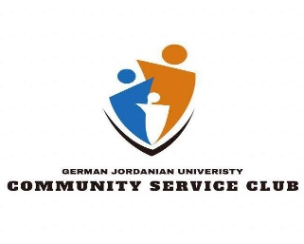 | Welcome to our community! We're a group of 900 dedicated members at the Community Service Club, led by President Aoun Altorman with the help of  8 special members  -Trteel Alqaimary  -Lujain Albustami  -Ahmad Hussam  -Bashar Alhasan  -Rachel Madaeen  -Dima Alssaheb  -Ghaith Falahat  -Mohammad Alhawamdeh  Vison of the Club: Our aim is to make a positive impact through volunteering. either through direct hands-on efforts or by fundraising for other organizations.  Mission of the club: We have previously organized impactful events such as iftars for orphans, free medical days, tree planting initiatives, and fundraising games weeks aimed at restoring a local school.  Looking ahead, we are enthusiastic about our upcoming events, including a summer club for student teaching, an awareness campaign promoting volunteer work, and initiatives to encourage school students to engage in volunteerism.  If you're interested in joining our community, we extend a warm invitation to you!  Please feel free to reach out to President Aoun Altorman at O.alturman1@gju.edu.jo or 0776079017. We eagerly anticipate welcoming you to our community
2. | Environmental & Health Club   | Promote environmental education and focus on some important environmental issues in the community.
3. | Robotics Club   | Introductory statement  The GJU Robotics Club is a meeting space for robotics and technology enthusiasts from every major. Meet like-minded peers and get helped from other talented students and professor for any project you may have in mind!  including number of members.  100+  The board member names:  Faris Al-Natsheh  Abdulrahman Al-Zamer  Khairi Saleh  Leen Alfityani  Khaled Ghazal  Abdullah Ahmad  Omar Qadibalban  Abdullah Azzam  Rami Al-Janini  Tareq Abeda  Ahmad Ayed  Ghassan Jayyousi  Sara Nimri  Abdulrahman Nawawi  Club vision:  To create a tight community for all those interested in robotics and software. The goal is to eventually grow these connections and develop useful professional connections.  Club mission  Participate in local robotics and software competitions, while also developing professional connections with other universities and companies  Past events  -Yearly robotics orientation game event  -Arduino courses  -Sumo robotics competition  -BAU Arduino competition  -JODDB Creative Initiative  -JCPC programming competition  Details about joing and contact emails and/or phone numbers of those in charge.  Faris Al-Natsheh f.alnatsheh1@gju.edu.jo  0770145155  Abdulrahman Al-Zamer  A.alzamer@gju.edu.jo  0792001830
 |  | The IT club at the German Jordanian University is a place for enthusiasts to grow their interests.  The students overseeing the club are:  Hazem Arar - President and director  Ward Al Barari - Vice President  Tareq Abeda - Projects team leader  Abdulrahman Al Nawawi - Social Media Team Leader  Raya Fasha - Communications Team Leader  Muayad Zaitoun - CTF Team leader  The club’s vision is to establish a society of pioneers in technological advancement and research. Our mission is to grow a passion for academic achievement amongst students. And to enrol in events and competitions with the hopes of succeeding.  past events section:  A network course that hosted more than 30 students and lasted a month.  A network workshop where we taught the students how to use Packet Tracer and more.  An online community through the "Discord" platform consisting of more than 130 members  Multiple online lectures and revisions given on the platform  We are currently working on introducing a competitive team, CTF team, research team, and project team to our club.  If you’re interested in joining the club, please contact us through:  Itclub.gju@gmail.com
5. | International Student Club   | _{What is the ISC?}  The International Students club was founded in 2015. Each semester we welcome the incoming exchange students with open arms. We focus on integrating our local students with the exchange student to make their experience more comforting while also allowing our students to benefit by further practicing their language skills as well as getting introduced to new cultures and backgrounds. This is done through various events and activities including board games nights, movie nights, sports games and various gatherings.  _{Mission:}  Our club aims to encourage cultural exchange, enriching views and opinions, while also forming friendships and creating memories.  _{Vision:}  Empowering global connections, fostering cultural exchange, and creating a supportive community, our International Students Club envisions a world where diverse perspectives thrive, friendships transcend borders, and every student finds a home away from home  Board Members:  Vice President  Halima AlGharabli  Head of Media:  Head of Public Affairs:  Bana Yasin  Ahmad Ayed Abu Ajamie  President      Tala Al Masri Vice President  Club advisor      Hamza Tuffaha  SABE coordinator    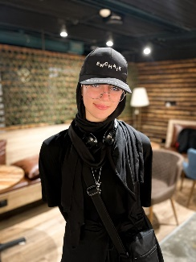  Nada Al Kilani  Event Organizers:  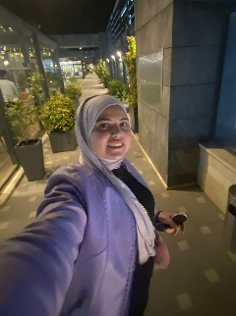  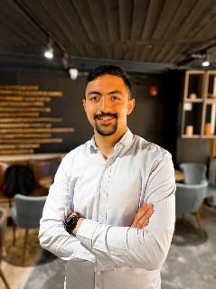    Lara Al Saket Ansam Masaadeh Abdallah Osaili
7. | Book-Busters club   | "Book Busters" aims at encouraging the younger generation to read more by presenting what they have read through acting with the help of the team members
8. | Model United Nations (MUN)   | - Model United Nations (MUN) is a realistic simulation of the United Nations and its affiliated specialized agencies and non-governmental organizations. Students from across the country and around the world convene to discuss and solve some of today’s most urgent issues from the perspective of a United Nations representative. By representing a nation in the Conference, students are challenged to learn, understand, and debate difficult issues from the perspective of their respective roles.  Some elements they must take into consideration are their selected roles and duties, as well as their countries’ visions, goals, foreign policies and economic strength.  - About GJU MUN German Jordanian University Model United Nations  (GJUMUN) is a conference that aims to provide the present generation with an authentic UN experience and provide a platform that enables the youth of Jordan to become a competent element in resolving international challenges, conflicts and crisis. MUN is a simulation of the UN; it is a political and academic competition where students learn about diplomacy and international affairs, while developing key strengths in teamwork, debate, communication, decision-making and problem solving.  3. Our Vision:  Constructing a deeper understanding of the current geopolitical state of the world among the new and current generations. To provide participants with an outlet to experience a simulation of impactful and key roles on the global scale under the UN umbrella. To further develop the participants’ communication and problem-solving skills in high-intensity environments. A teaching opportunity for those interested in UN procedures, court procedures, and world history. To provide a networking opportunity between similar-minded and highly competitive individuals under the scope of the MUN.  4. Our Mission  To allow the new and current generation to become more aware of the surrounding conflicts in the region and educate them further on the history and the context behind it. The event also allows them to hone their leadership and debate skills throughout 3 days of hard work that requires a sharp diplomatic sense, extensive knowledge, and good teamwork.  5. Event Description  GJUMUN will be held from the 12th to the 14th of September. The event will consist of approximately 150-200 participants performing roles as delegates, staff, media, security, judges, advocates, chairs and presidents of committees, and the organizing team. The event will take place over 3 days of lobbying and debate sessions, while also providing coffee breaks and lunch in between sessions. The first day will consist of lobbying and merging, where delegates and other advocates in the MUN discuss the topic amongst themselves and join in on agreements, and treaties, form alliances, and construct a plan. The following 2 days will consist of heavy debate sessions and UN procedures progressing the topic into a main goal: to develop resolutions and conclude the given topics of interest positively.  6a. Proposed Schedule  Day 1 (GJU Campus) Doors Open 5:00 Registration 5:30-6:00 Lobbying and Merging 1 6:00-730 Coffee Break 7:30-8:00 Lobbying and Merging 2 8:00-9:30  Day 2 (Hotel) Doors Open 9:00 Opening Ceremony 10:00-11:30 Coffee Break 11:30-12:00 Debate Session 1 12:00-2:00 Lunch 2:00-3:00 Debate Session 2 3:00-5:00 Coffee Break 5:00-5:30 Debate Session 3 5:30-7:30  Day 3 (Hotel) Doors Open 9:00 Debate Session 1 9:30-11:30 Coffee Break 11:30-12:00 Debate Session 2 12:00-2:00 Lunch 2:00-3:00 Debate Session 3 3:00-5:00 Coffee Break 5:00-5:30 Debate Session 4 5:30-7:00 Closing Ceremony 7:00-8:30  7. Proposed Schedule: Our Requests  The first day will be held on the university’s campus, the second and third days are expected to be held at the Hotel. During the second and third days, it is expected that 7 conference rooms will be needed for the committees and staff. The committees require a coffee break inclusive of coffee, tea, and pastries provided in an open area inside the hotel. (twice per day) Allow sponsors to display their banners in the dedicated areas near the committees, as well as a few dedicated booths. Lunch is required to be held at the designated place by the hotel for all participants at once. (once per day) The opening and closing ceremonies require a large room fitted with microphones, sound systems, and a projector with Internet connectivity. The room should be able to fit approximately 250 people, which will include guests and sponsors in addition to the participants. Platinum Sponsorship - 2000 JDs 1. Speech of gratitude and token of Appreciation. 2. Brochures and leaflets will be distributed in every participant file. 3. Unlimited number of banners/ roll-ups distributed wherever seen fit by the sponsor. 4. Two booths set up wherever required. 5. Adding the logo on all social media posts except for ceremonial posts. (Recognition as Diamond Sponsor). 6. Dedicated posts about the sponsor with higher frequency during the weeks leading up to the conference. 7. Sharing a video/interview about the sponsor on the page. 8. Recognizing them as Diamond Sponsors in both opening/closing ceremonies. 9. A video of their choosing shown in the opening Gold Sponsorship - 1500 JDs 1. Speech of Gratitude and Token of Appreciation. 2. Brochures, leaflets will be distributed in every participants folder. 3. Four banners/roll-ups distributed wherever seen fit by the sponsor. 4. A booth set up wherever required. 5. Adding the logo on all social media posts except for ceremonial posts. (Recognition as Platinum Sponsor). 6. Dedicated posts about the sponsor every 10 days. 7. Recognising them as Platinum Sponsor in both opening/closing ceremonies. 8. A video of their choosing shown in the opening Silver Sponsorship - 1000 JDs 1. Speech of Gratitude and Token of Appreciation. 2. Brochures and leaflets will be distributed in every participant's folder. 3. Four banners/roll-ups distributed wherever seen fit by the sponsor. 4. Dedicated post about the sponsor. 5. Recognising them as Golden Sponsors in both opening/closing ceremonies. Bronze Sponsorship - 650 JDs 1. Speech of Gratitude and Token of Appreciation. 2. Brochures, leaflets will be distributed in every participant folder. 3. Two banners/roll-ups distributed wherever seen fit by the sponsor. 4. Recognising them as a Silver Sponsor in both opening/closing ceremonies. Catering Sponsorship As a sponsor of this event, we would like to offer you the opportunity to provide refreshments and snacks for one coffee break on the first day of the MUN serving approximately 200 participants. This would give you the chance to showcase your delicious and high-quality beverages and snacks to the delegates, who will be relying on you to keep them fueled and refreshed throughout the first day of the conference. In return for your support, we would be pleased to offer you the following benefits: 1. Speech of Gratitude and Token of Appreciation. 2. Brochures and leaflets will be distributed in every participant’s folder. 3. Four banners/roll-ups distributed wherever seen fit by the sponsor. 4. Recognizing them as the Catering Sponsor in both opening/closing ceremonies, and all media outlets. 5. Sponsor's logo present in conference-related documents Stationary Sponsorship As a sponsor of this event, we would like to offer you the chance to provide stationary for 200 students. This would give you the chance to showcase your high- quality products, to the delegates. The required items include: 8-10 roll up banners 150-200 badges 150-200 certificates 120-150 tri folded plaque cards 150 folders that include a note book and a pen 200 leaflets *all numbers are approximate. In return for your support, we would be pleased to offer you the following benefits: 1. Speech of Gratitude and Token of Appreciation. 2. Brochures, leaflets will be distributed in every participant folder. 3. Three banners/roll-ups distributed wherever seen fit by the sponsor. 4. Recognizing them as the Catering Sponsor in both opening/closing ceremonies, and all media outlets. 5. Sponsor's logo present in conference-related documents  7. Our Requests  The first day will be held on the university’s campus, the second and third days are expected to be held at the Hotel.  During the second and third days, it is expected that conference rooms will be needed for the committees and staff.  The committees require a coffee break inclusive of coffee, tea, and pastries provided in an open area inside the hotel. (twice per day)  Allow sponsors to display their banners in the dedicated areas near the committees, as well as a few dedicated booths.  Lunch is required to be held at the designated place by the hotel for all participants at once. (once per day)  The opening and closing ceremonies require a large room fitted with microphones, sound systems, and a projector with Internet connectivity. The room should be able to fit approximately 250 people, which will include guests and sponsors in addition to the participants.
9. | Theater and Drama club   | Showing plays about the student topics and some issue in the community
10. | Business Students Club ( BSt)  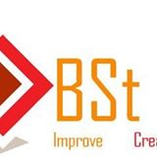 | Execute some activity related with business and mini project.
11. | Industrial Engineers Club  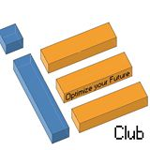 | Industrial Engineering Club (German Jordanian University)  Welcome to the Industrial Engineering Club (IEC) at GJU, where the gears of innovation and excitement never stop turning! we’re a crew that loves to dive deep into the world of industrial engineering while keeping the vibe fun and fresh. Whether you're looking to turbocharge your skills, network with the pros, or just have a blast with fellow engineering enthusiasts, the IEC is your go-to hub. Join us to spark your creativity, meet your future besties, and engineer your path to success. Gear up, get involved, and let’s make some industrial magic happen together.  Board members:  President: Leen Al-Tarifi  vice president : Layan Qteishat  membership manager : Jumanah Alrawajfeh & Zeyad Ahmad  Treasurer : Saif Rahahleh  marketing officer : Amrou Chaban  Academic liaison manager : Ahmad Zatari  Our Vision:  Our vision is to cultivate a vibrant and inclusive environment where every student can thrive. At the Industrial Engineering Club, we're committed to unlocking each member’s full academic and personal potential. We prepare students for the challenges and opportunities of the future, empowering them with the confidence to excel in their careers and beyond. Join us to transform your journey into one of innovation, success, and self-assurance in the dynamic field of industrial engineering.  Our mission:  - Our main goal is to expand our members' knowledge of industrial engineering through a mix of hands-on projects and insightful lectures. We aim to bridge theory with practice, ensuring that every club member gains both a deep understanding and real-world experience in the field. Join us to transform your learning into action and become a well-rounded industrial engineer ready to tackle the challenges of tomorrow.  - We keep our members at the forefront of the latest trends in the job market and industrial engineering. By staying updated, our club ensures that you are not just ready but ahead of the curve, well-prepared to seize new opportunities and tackle emerging challenges in the industry.  - We host signature events featuring prominent industrial engineering organizations. These gatherings provide unique opportunities for our members to network, learn from industry leaders, and gain exposure to the cutting-edge developments shaping our field.  - We are dedicated to developing essential engineering skills, fostering a strong sense of ethics, and enhancing decision-making abilities. Our activities and programs are designed to build a solid foundation that prepares our members to excel as professionals and leaders in the industrial engineering community.  Events :  We organize site visits and seminars with experts in the field of industrial engineering, providing students with invaluable insights and advice drawn from real-world experience. These opportunities not only deepen their understanding of their major but also connect theoretical knowledge with practical applications. Additionally, we offer guidance to help students with their academic planning and registration processes. We also support the Department of Industrial Engineering by offering assistance where needed, ensuring both students and the department benefit from our initiatives.  How to Join :  Instgram: iec_gju  Whatsapp : leen tarifi ( +962 796512542)  Layan Qteishat (+962 777480747)  Or ask about us in DSA  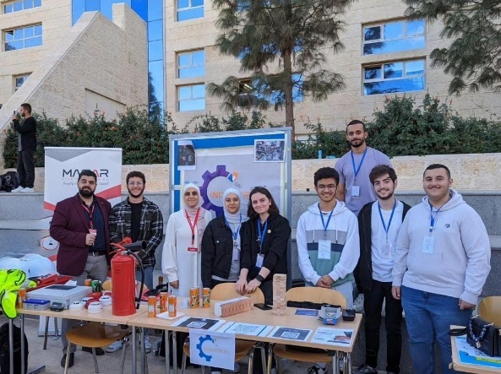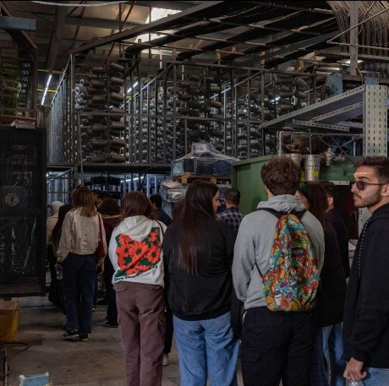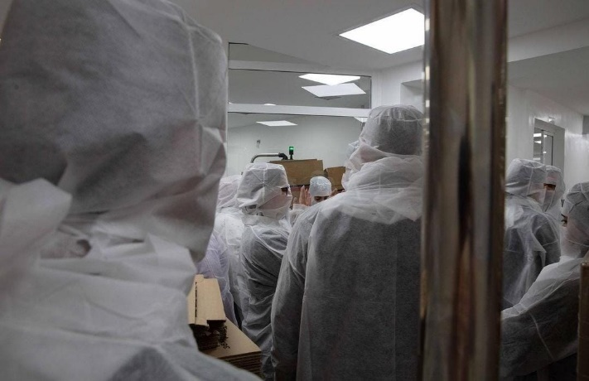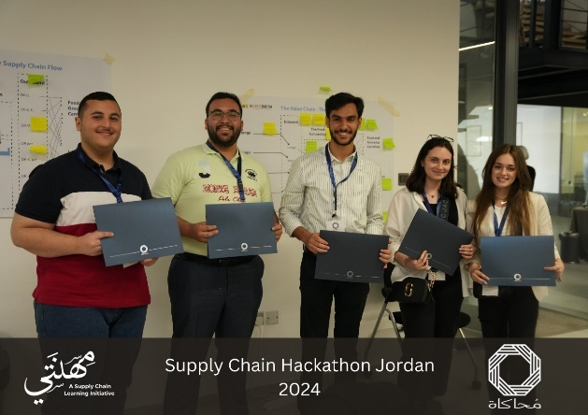  Training and workshops related with industrial engineering
12. | Arabic club   | Interest with Arabic language by celebration of special events in the Arabic language and encourage reading
13. | IEEE   | IEEE German Jordanian University Student Branch  The IEEE German Jordanian University (GJU) Student Branch is a vibrant community of engineering students established in 2011. We are affiliated with the Institute of Electrical and Electronics Engineers (IEEE), the world's largest professional association for the advancement of technology.  Mission is to foster a dynamic environment where GJU students can:  - Deepen their knowledge: We organize workshops, seminars, and guest lectures led by industry experts and academics, providing exposure to cutting-edge advancements in engineering fields.  - Develop professional skills: Through workshops and project-based activities, we equip students with valuable skills like technical communication, teamwork, and problem-solving - sought after by employers worldwide.  - Network and connect: We host social events and offer opportunities to connect with fellow engineering students and professionals, fostering collaboration and building a strong network within the engineering community.  - Gain global exposure: Being part of the IEEE network grants access to international conferences, online resources, and publications, keeping students abreast of global trends and developments in their chosen fields.  The IEEE GJU Student Branch is led by a dedicated team of student officers who work tirelessly to provide a rich and rewarding experience for all members. We actively collaborate with the university administration, faculty, and other student organizations to offer a comprehensive learning experience for GJU's engineering students.  Award-Winning Excellence  We are proud to be recognized as one of the best branches in the region! Our dedication to providing a valuable and enriching experience for our members has been acknowledged through this prestigious award.  Available Societies:  The IEEE GJU Student Branch offers a variety of focused communities aligned with specific technical interests. Here's a glimpse into some of our active societies:  - IEEE Women in Engineering (WIE): WIE empowers women in engineering and related technical fields by providing professional development, networking opportunities, and scholarships.  - IEEE Industrial Electronics Society (IES): The IEEE Industrial Electronics Society focuses on applying electronics and electrical engineering to improve industrial and manufacturing processes. This includes advancements in robotics, automation, data acquisition, and power electronics. The society constantly adapts its activities to address the latest needs of modern industry.  - IEEE Computer Society (CS): The Computer Society is the world's premier source of information on all aspects of computer science and engineering.  - IEEE Engineering in Medicine and Biology Society (EMBS): EMBS bridges the gap between engineering and life sciences, addressing the application of engineering principles in healthcare and medical research.  - IEEE Consumer Technology Society (CTSoc): This society keeps members informed about the latest advancements in consumer electronics and technologies impacting everyday life. This society is also the first in the region!  - IEEE Robotics and Automation Society (RAS): RAS is a leading community for robotics and automation professionals, fostering research, development, and application of robotics technologies.  - IEEE Industry Applications Society (IAS): IAS focuses on the application of electrical and electronic technologies in industries like power and energy, manufacturing, and transportation.  Join us!  We welcome all GJU students with a passion for technology and engineering to join our growing community. Membership in the IEEE GJU Student Branch opens doors to a world of professional development, networking opportunities, and a chance to shape the future of technology.  A Dedicated Team:  The IEEE GJU Student Branch is led by a passionate team of student officers who work tirelessly to provide a rich and rewarding experience for all members. Our current leadership team consists of:  - Chair: Faisal Abunameh  - Vice Chair: Khaled Shweikeh  - Treasurer: Mohammad Al Mohammadi  - Secretary: Raya Fasha  - Social Media Officer: Maya Al Bohairi  We are a branch of over 90 enthusiastic GJU students, and we welcome all those who share our passion for engineering and technology to join our community!  Contact:  For more information on how to become a member or get involved in our activities, please visit our website https://edu.ieee.org/jo-gju/ or our Instagram account https://www.instagram.com/ieeegju/ or even through our email https://edu.ieee.org/jo-gju/  Our Gallery of events:  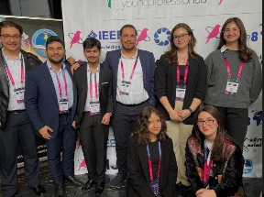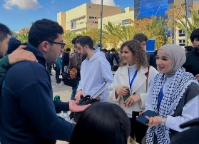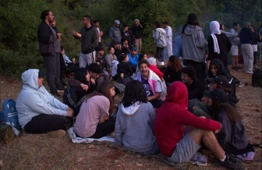
14 | MOTOR CLUB | Motorsports Club GJU is a club that serves the passion of motorsports young enthusiasts within our university. Joined by 200 members from a single semester, with a shared interest in cars and racetracks, the club provides a platform for like-minded students to learn, share knowledge, and engage in events that fuel their passion, all within a safe and supportive environment.  The club has 7 board members, with Abdullah Almousa serving as the president and Waseem AlSalaitah as the vice president.  Followed by three team leaders: Hashim Toghoj, who leads the business development team. Zaid Sharkas, who leads the offline marketing team. And Mohammad Al Sarhan, who serves as the online marketing lead and content creator.  In support of these teams, board member Saif Al Mousa takes on the role of Talent Management, as well as documentation and reporting. And Aya Harahsheh serves as the treasurer.  Mission: At GJU Motorsports, our mission is to cultivate a vibrant and dynamic community of motorsports enthusiasts who are not only passionate about the exhilaration of racing but also committed to excellence, safety, and sustainability.  Vision: At GJU Motorsports, our vision is to be a trailblazing force in the world of motorsports, inspiring a new generation of enthusiasts who are not only adept in the thrill of racing but also embody the principles of innovation, safety, sustainability, and community impact.  Past events: The club organized a successful movie night at the SABE Campus, where members gathered to watch a classic movie centered around motorsports.  Upcoming events: The club is currently engaged in a Formula Student project, which is an educational engineering competition in Europe. This competition, supported by industry experts like Ross Brawn OBE, aims to foster the development of innovative young engineers and inspire more individuals to pursue careers in engineering. With the participation of over 100 university teams each year, students have the opportunity to apply real-life applications to their studies.  The project involves the design, assembly, and manufacturing of a Formula Student race car, with each engineering student specializing in specific areas such as chassis, aerodynamics, suspension, powertrain, electrical, and race engineering. The project is supported by business development teams responsible for logistics, finance, marketing, and sponsorships, as well as project management teams handling performance management, documentation and reporting, risk mitigation, and talent management. Currently, the project is in the capacity building and initiating the design phase.  Joining the club is open to new members every semester, including the summer semester. The club recruits through various avenues, such as club orientation booth events held on campus and other introductory events. Social media platforms also play a significant role in raising awareness and attracting new members to join the club.  Contact info.  Abduallah Almousa +962 79870 8966 a.almousa@gju.edu.jo  Waseem AlSalaitah +962 77705 3072 w.alsalaitah@gju.edu.jo
15 | Society Club | Welcome to the vibrant community of the Society Club at the German Jordanian University (GJU)! With a dynamic team of dedicated individuals, we are committed to fostering a culture of social engagement and active citizenship among our members.  Board Members: • President: Zaid Adel Albalawnah Vice President: Abdullah Zaid Alzu’bi Etedal Taher Ereiqat Leen Alaa Hussain Omar Abdalkareem Arabeyyat Iman Mohamed Aboushiwa Mohannad Mountasser Mismar • Maryam Hisham Al-sammarraie  Club Vision: Our vision is to create a dynamic and inclusive environment where every student at the German Jordanian University feels empowered to participate in various activities, express their creativity, and build lasting relationships. Through our initiatives, we aim to increase awareness and understanding of important societal issues, inspiring students to become compassionate and socially responsible leaders who contribute positively to their communities and beyond.  Club Mission: The mission of the 'Society' Club at the German Jordanian University is to empower students to actively engage in diverse activities, nurturing their creativity, fostering meaningful relationships, and cultivating a vibrant campus community. We strive to provide a platform where students can explore their interests, collaborate with peers, and develop valuable skills while promoting inclusivity and diversity  Past Events: One of our recent successful events was the GJU Schools’ Challenge, held on April 4th, 2024, during the final days of Ramadan. This event featured spirited competitions between university schools, engaging students in various challenges and fostering camaraderie and teamwork. Also, the club has organized the clubs IFTAR at the same day where students and specially clubs’ members gathered at the Iftar table in the holy month of Ramadan. The club is also planning for a second version of the schools’ challenge next year.  Upcoming Events: Mark your calendars for our upcoming  Society Day on May 15th, 2024, at the university campus! Join us for a day filled with exciting activities, discussions, and opportunities to connect with like-minded individuals who are passionate about social change and community impact.  Contact Information: For inquiries, membership, or collaboration opportunities, please reach out to us via email at gjusocietyclub@gmail.com. Stay connected with us for updates and announcements on our social media channels. We look forward to welcoming you to our Society Club family!
16 | Innovation Club | Introduction: Entrepreneurship and innovation.  The club aims to develop and enhance entrepreneurship and innovation skills.  The club is a platform for individuals to learn and exchange knowledge in the field of entrepreneurship. It may include activities such as workshops, lectures, orientation sessions, networking opportunities with successful entrepreneurs, trips to factories or other universities, and events that connect science and entertainment at the same time.  Number of members : 717 member  Board members :  1.Mohannad Awawdeh. (President)  2.Sanad Al-Haj Ali. (Vise President)  3.Shafiq Alsaloul.(Event Management)  4.Ameen Alsadi .(Public Affairs)  5.Khaleel Alkorom .(Media)  6.Serena Haddad.(Public Affairs)  7.Amanda Kharadsheh.(Public Relations)  Club vision :The club looks forward to reaching out to all students, influencing them, developing their ideas and making them creative and entrepreneurial students in all matters of their lives.  Club mission:Holding events that integrate the scientific, creative and entertainment aspects  Holding activities inside and outside the university, competitions and holding some courses.  Past events:  - Visit to the Royal Jordanian Air Academy  - Participation in the Middle East Space Conference  - Ramadan Ifftar  - Entrepreneurship courses with orange company  and many other events...  Upcoming events :  -Creative treasure hunt competition.  -Visit to the Ministry of digital economy.  -Visit to the Orange Center and the innovation department at the National Bank.  -Holding several courses.  and many other events...  Innovation Club :  https://chat.whatsapp.com/BTqMn5xOm0JAeLCjuMOeVN  https://www.instagram.com/innovationclub.gju?igsh=MWdvM3lnbW9wbDlrbA==  m.awawdeh1@gju.edu.jo  +962789669979
17 | Art Club | Who We Are  We are a group of 150-200 passionate artists from the GJU main campus and SABE who are committed to supporting the artistic talents of the students in GJU and unleashing their potential. The club will ensure the university’s presence in art competitions across Jordan while also assuring that we present the university well in the art community, and hopefully winning Awards under the name of our university.  Mission:  - To provide a collaborative platform for all members in our university who share a passion for the arts. Through a variety of creative activities and workshops, we aim to foster creativity and use art to spread awareness on vital societal issues.  Vision:  - We envision a club that inspires, empowers, and celebrates the artistic talents of GJU students, creating a community within the university, one that knows no bounds.  Board member:  Art club president: Yaqeen Shalabi  Vice presidents: Marah Daghlass and Aseel Dabain  Etedal Eriqat  Zein Sultan  Leen Awwad  Aysha Sakher  Anas Raid  Past events  Art gallery  Wijdan art space workshop  SABE workshop  Iftar al kheir  Upcoming events  Art therapy session  Mural painting at SABE  Independance day  Join through the whatsapp link:  whatsapp group  Official club instagram:  @gjuartclub  Club contact information:  Yaqeen Shalabi:  Y.shalabi@gju.edu.jo  0772033395  Marah Daghlass:  0797714115  Aseel Dabain:  0777400513  A.dabain@gju.edu.jo

